A Multi-Parameter Water Quality Monitoring System Using 8086 Microcontroller and ADC0808

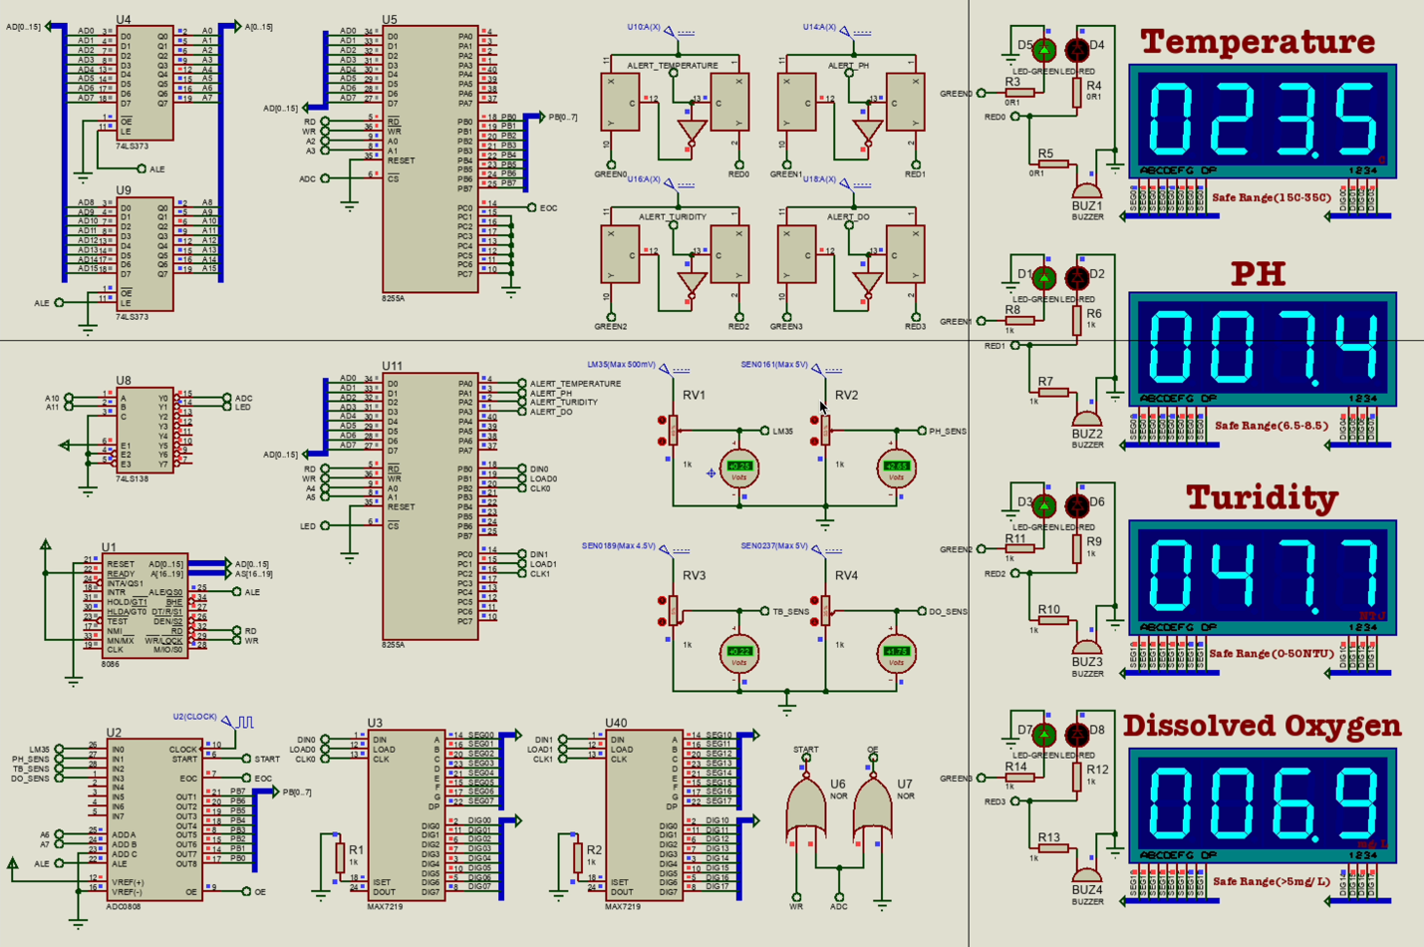

System Architecture:

* Uses sensors (Temperature, pH, Turbidity, DO) to measure water quality.
* Employs an **ADC0808** to convert analog sensor signals to digital.
* Uses an **8051 microcontroller (AT89C51)** to process and display data.
* Drives **7-segment displays** using **MAX7219**.
* Triggers **alerts** using **comparators (LM339)**, LEDs, and buzzers if readings are out of safe range.

Detailed Flow

1. Sensors & Signal Conditioning

Each sensor is connected through a voltage divider (variable resistor for calibration):

* **RV1 + LM35** → Temperature sensor
* **RV2 + pH Sensor** → pH level
* **RV3 + Turbidity Sensor**
* **RV4 + DO Sensor**

These output analog voltages proportional to the measured parameters.

### **2. Analog Multiplexer (U2 - ADC0808)**

* Accepts 8 analog input channels (A0–A7).
* Converts selected analog signal to digital using 8-bit resolution.
* Controlled via select lines (A, B, C) from the microcontroller.
* **OE**, **START**, **EOC**, and **ALE** are control signals for synchronization.

### **3. 8086 Microcontroller (U1)**

* Central processor that:
  + Selects ADC channel.
  + Starts conversion.
  + Waits for **EOC** (End of Conversion).
  + Reads converted 8-bit value.
  + Sends data to display.
  + Checks thresholds and activates alarms.

### **4. Display Driver (U3, U40 - MAX7219)**

* **MAX7219** takes SPI input from 8051 and drives 7-segment displays.
* 4-digit 7-segment display used for each parameter.
* Each parameter has its own MAX7219 driving it (DIG0–DIG3).

### **5. Alarms (Comparators + LEDs + Buzzers)**

* **LM339 quad comparator** is used for each parameter.
* Receives:
  + One input from sensor signal (via voltage divider).
  + One input from reference voltage (threshold).
* If the sensor value exceeds the reference:
  + Comparator output goes HIGH.
  + Drives RED LED + BUZZER for that parameter.
  + Activates corresponding alert signal to microcontroller.
* Alerts:
  + ALERT_TEMPERATURE
  + ALERT_PH
  + ALERT_TURBIDITY
  + ALERT_DO

### **6. Multiplexing & Control Logic**

* 74LS373, 74LS573, 74LS138 (U4, U5, U8, U9, U11) handle:
  + Data/address multiplexing.
  + Output enable control.
  + Chip selection.
* Used to expand addressable memory/data lines for the 8051.

### **7. Control Logic for Timing (U6, U7)**

* NOR gates combine control signals:
  + Ensure correct timing between ADC **START**, **WR**, **ALE** signals.
  + Avoid data corruption during ADC reading.

Displays

**7-Segment LEDs**

* 4 separate sections showing:
  + **Temperature** – LM35 (display in °C)
  + **pH** – pH Sensor (0–14 scale)
  + **Turbidity** – in NTU (Nephelometric Turbidity Units)
  + **Dissolved Oxygen** – in mg/L
* Each has:
  + 4-digit display
  + Green/Red LED based on safety range
  + Buzzer for alert
  + Safe range labeled for reference

### **Threshold Values and Alert Conditions**

|  |  |  |  |
| --- | --- | --- | --- |
| **Parameter** | **Safe Range** | **Alert Condition** | **Signal** |
| Temperature | 15–35°C | <15 or >35 triggers alert | ALERT_TEMPERATURE |
| pH | 6.5–8.5 | Outside this range | ALERT_PH |
| Turbidity | 0–50 NTU | >50 triggers alert | ALERT_TURBIDITY |
| Dissolved Oxygen | >5 mg/L | <5 triggers alert | ALERT_DO |